**Flutter App**

Kard Store

LC034 – Ryne Ferdinand

Repository Link: <https://github.com/RyneFerdinand/LC034-Qualification-Flutter.git>

Kard Store is an online card shop that sells yu-gi-oh card packs. The features of the apps are explained below:

1. Login Page

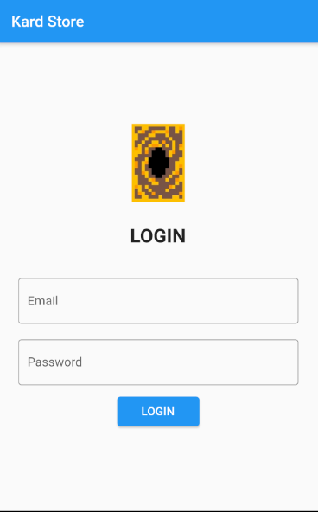

Above is the login page, the user will need to input their email and password if they want to login to the app. To be authorized, the email has to be filled, contains ‘@’, ends with ‘.com’, and has length more than 5, while the password has to be filled and be more than 4 characters. After the user fills the text fields, the app will validate. If it’s invalid, the app will show an error message below the text field. While if it’s valid, the app will redirect to home page.

1. Home Page

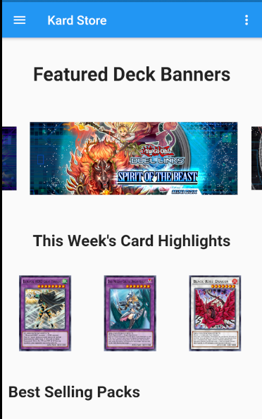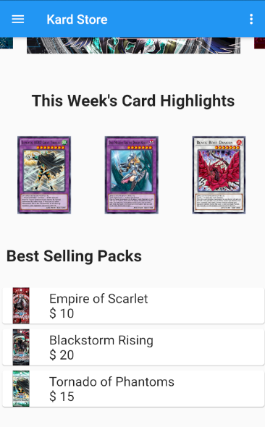

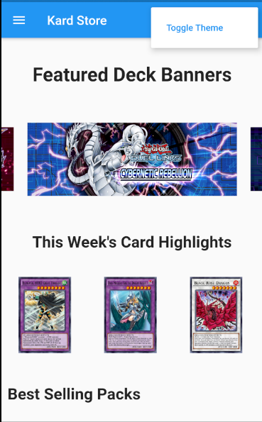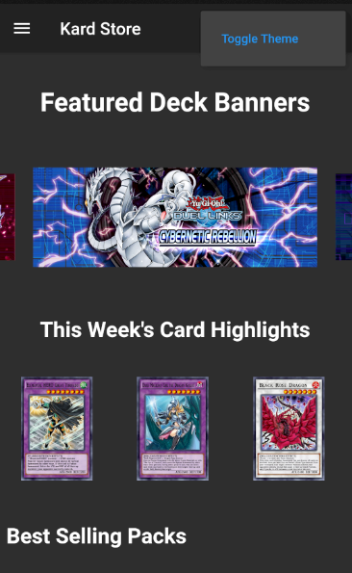

Above is the home page, the home page displays the featured deck banners in the form of carousel, this week’s card highlights, and the best-selling packs. There is also a toggle on the top right to change the theme of the page to light or dark mode.

1. Navigation Bar

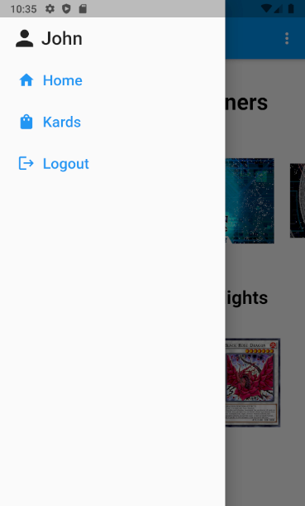

This is the navigation bar, it shows the username of the person that’s logged in and 3 other buttons to navigate (home, kards, logout). The home button will navigate the user to the home page, the kards button to the item list page, and the logout button is used to logout, in which the user will move to the login page.

1. Kard List

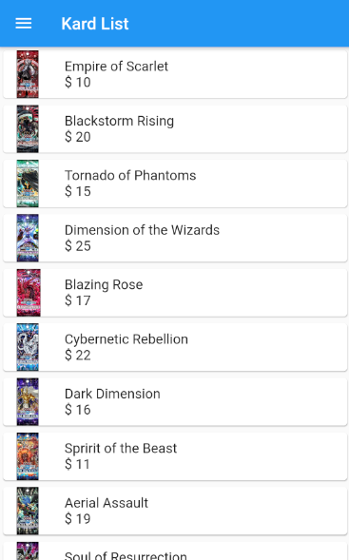

This is the kard pack list page, here the user can view the kard packs that are sold in the store. The user can see the card pack, the pack name, and the pack’s price. The user can press the list item to redirect to the detail page.

1. Detail Page

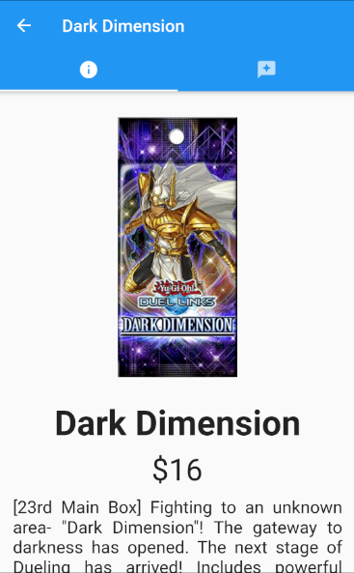 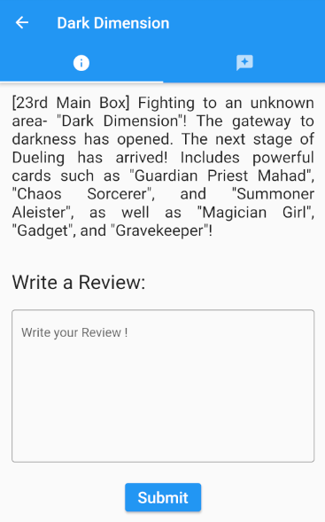

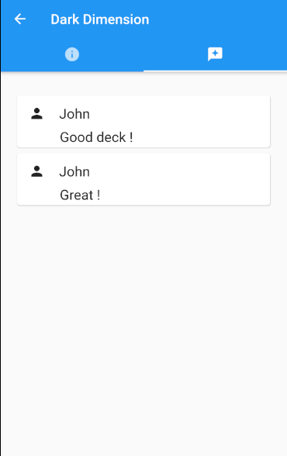

This is the detail page, in the first tab, it shows the pack’s image, pack’s name, pack’s price, and the pack’s description. The page will also give a review text field, in which the user can input reviews. The review can’t be empty. If it’s empty, it will show an error message. The second tab shows reviews that has already been written.